**Project Summary Form for Existing Duck Stamp, Upland Game Bird Stamp and Habitat Conservation Fee Projects**

**Project Title:** Using hunter and population survey data to investigate shared drivers of upland game bird populations and forecast future hunting conditions in Nevada.

**Principal Investigators:** Dr. Daniel Gibsonand Dr. Erik J. Blomberg.

1. **Project Summary:** Upland game birds are popular quarry among hunters, but have traditionally received less monitoring attention than other game such as waterfowl or big game. The dynamics of many upland game populations are poorly understood as a result, which both complicates management and provides a dearth of information to stakeholders, including hunters, about population status. In Nevada, annual surveys of hunters provide information on hunter effort and total harvest for each of the state’s upland game species. For a few species, specifically chukar and greater sage-grouse, detailed historic population survey data also exist. If upland game bird populations respond similarly to background environmental factors (e.g. presence of drought conditions) among species, it is likely this suite of data can be used to infer historic population dynamics and predict future patterns based on environment-covariate relationships and shared variance among data sources. Here, we propose to use a Bayesian Structural Equation Modelling (SEM) approach to 1) investigate patterns in upland game bird harvest and hunter effort and ask whether each covaries among species; 2) to relate species-specific population survey data with measured weather conditions; 3) to link species-specific harvest data with population-weather relationships, taking advantage of interspecific covariance patterns; and 4) ask whether harvest or populations have changed over the last 40+ years in Nevada. Based on these results, we will 5) develop a predictive model that can forecast likely annual populations and hunter success based on conditions experienced prior to the hunting season. This work will take advantage of existing data sources and use information on the shared, latent linkages among species to provide novel insights into harvest and population trends, and with this information will provide a tool for more efficiently communicating hunting season forecasts and long-term population trends. This will provide a tremendous benefit over traditional approaches that relied on labor-intensive, and in some case dangerous, surveys (e.g. chukar helicopter flights) to track populations and predict hunting season conditions.

**Objectives:** Our core goals are the following:

1. Determine how annual harvest of upland game species covary through time.
   1. Establish the extent to which the number of animals harvested each year is driven by variation in hunter numbers relative to the underlying population dynamics of the species. I.e., if we can control for variation in numbers of hunters, can total harvest be used as representative of population abundance?
   2. Evaluate how similar species are to one another with respect to annual harvest trends. If there are shared patterns (covariance) in number of birds harvested or total hunter effort among species, then this suggests that when more detailed information is available for one species, it can be useful to inform patterns in other species.
2. Evaluate predictive relationships between environmental conditions and population dynamics for species with robust historic population survey data (e.g. chukar).
   1. In semi-arid systems like the Great Basin, we assume that annual variation in temperature and moisture drive drought conditions, and these in turn affect upland game populations. Variables that measure moisture availability (e.g. drought severity indices) should thus be predictive of annual changes in abundance.
   2. Based on long-term data on chukar abundance from helicopter surveys, we can determine how annual abundance varies based on prevailing conditions.
3. Link species-specific patterns in annual harvest with patterns in survey data for species in which these data are available (e.g., chukar).
   1. If the harvest of species tends to be similar year to year (i.e. the covariances measured in objective 1) then the predictive relationships from well-surveyed species (objective 2) should be useful for informing predictions of harvest success and fall population size for species that lack survey data.
   2. Our approach will integrate across these two data types (hunter and population surveys) to determine the extent to which chukar populations, and the environmental conditions associated with them, can inform estimates of harvest for other species.
4. Evaluate long-term changes in species abundance based on hunter survey data.
   1. Because hunter survey data has been collected for as much as 40 years, once we establish a functional model it will provide the first opportunity to evaluate long-term trends in many upland game species while controlling for variation in hunter effort.
5. Develop a predictive tool to forecast fall populations and expected hunter success.
   1. As traditional methods for offering hunters a fall population forecast have been resource-intensive and dangerous (e.g. helicopter surveys for chukars), a forecast tool informed by our models offers a more efficient and safer alternative.
   2. This tool could be implemented as a web-based application, and updated to improve accuracy as additional years of information are collected for validation.
6. Use these associations developed in Objectives 1, 2, and 3 to develop a predictive model to forecast fall populations based on environmental conditions during the previous year. We also propose a web application product to apply model predictions and provide the public with information regarding potential regional and specific-specific hunting opportunities, as well as projections of species-specific population trends.
7. **Study Area:**

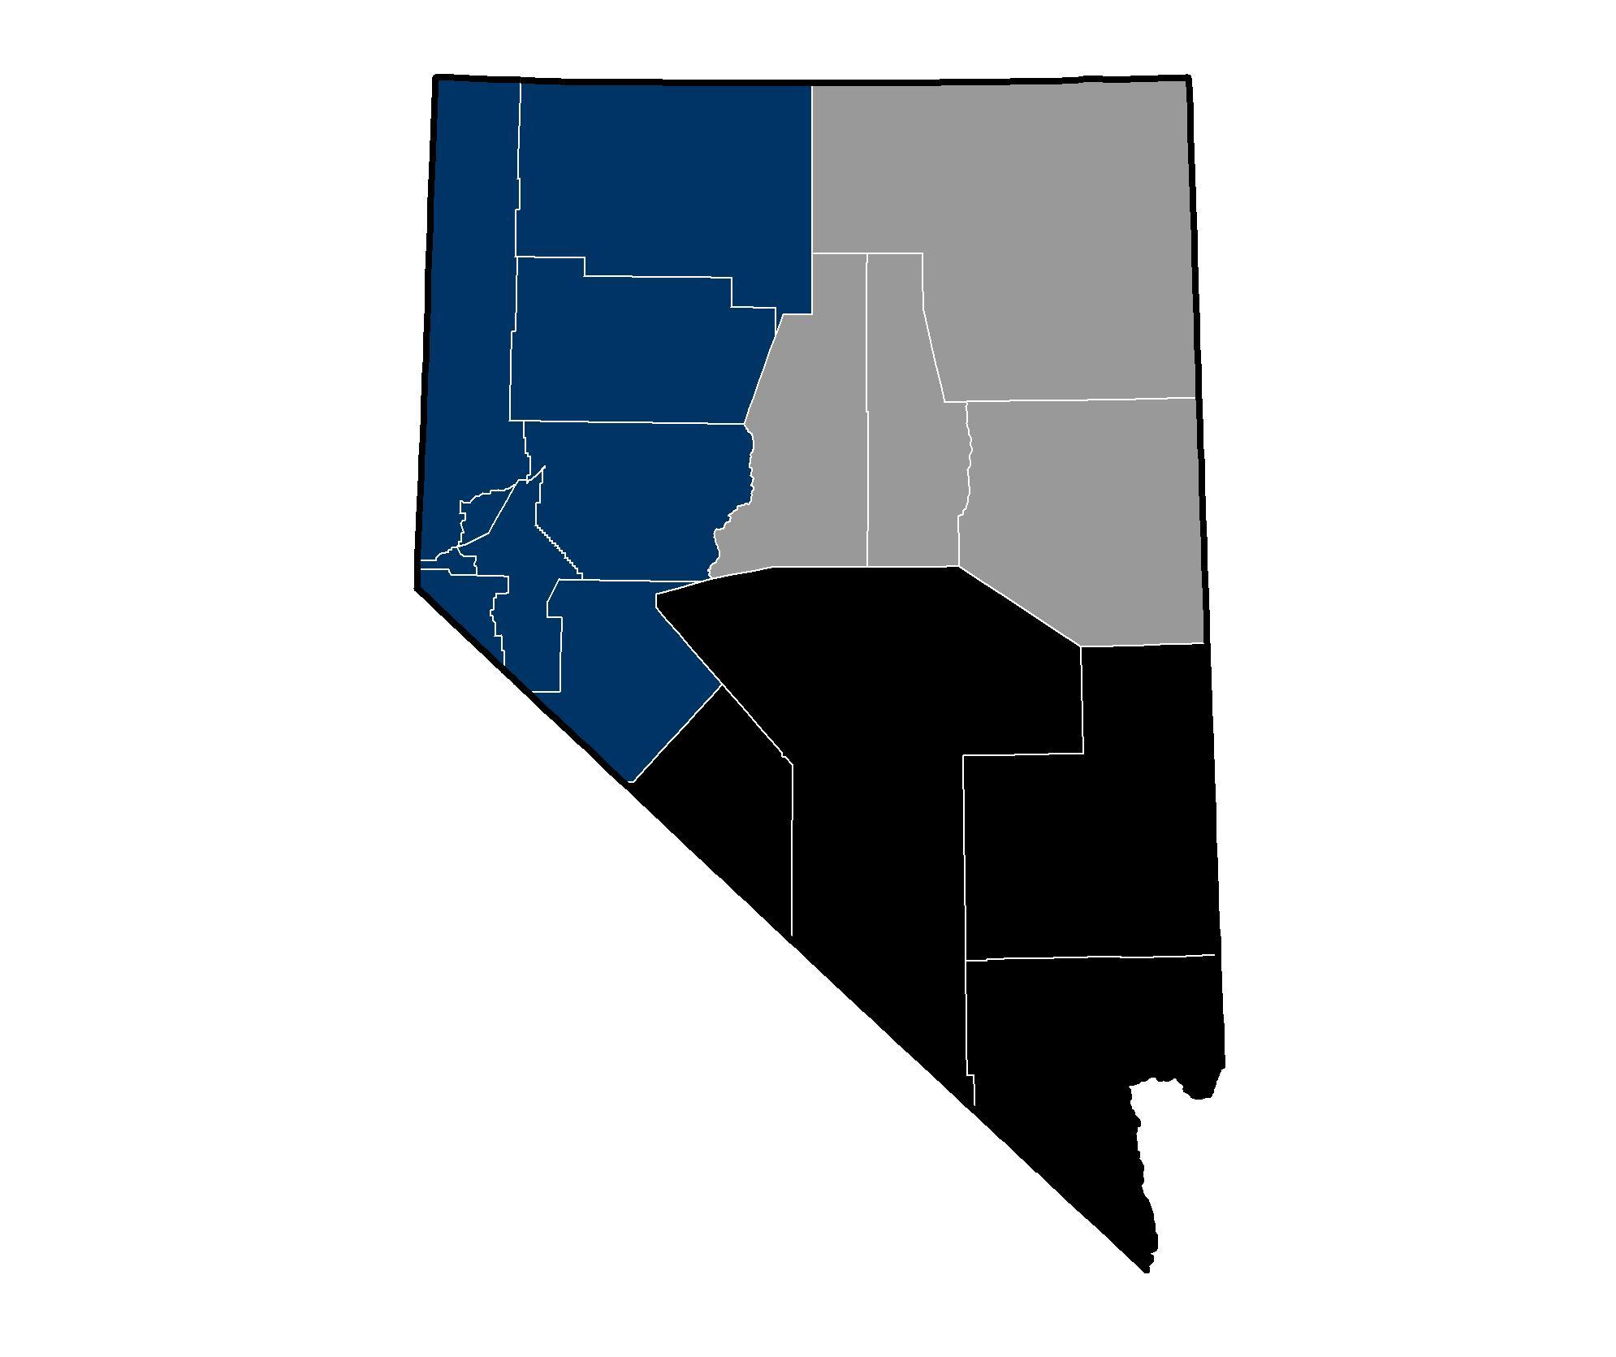**Figure 1**. The primary objectives of this study are to focus on patterns in population dynamics within and among upland species in the western (blue) and eastern (silver) regions of Nevada. Given the similarities in upland community composition between these two regions, it serves as a natural approach to validate models and improve inference. The southern region (black) may be used to explore the predictive power of modelled dynamics across space and time.

1. **Private or public:** Data are primarily generated from public lands
2. **What public land:** All public lands (at least in Northern Nevada)
3. **UTM:** See Figure 1.
4. **Approach:** This project will focus on using existing harvest and population survey data to establish patterns in the harvest and abundance of upland game species in Nevada over the last 40 years (1980-2019). We will focus on species with relatively large overlapping distributions, and plan to include grouse (greater sage-grouse, blue, and ruffed grouse), quail (California, and mountain quail), dove (mourning and white-winged dove), partridges (chukar and Hungarian partridge), and rabbits (cottontail, pygmy, and white-tailed jack rabbits). We plan to focus on the western and eastern regions of Nevada given the greater degree of similarity in species composition, habitat, and broad climate patterns in those regions.

The main data for the work will take two forms: existing harvest data (estimates of number of birds shot) collected from Nevada upland hunters through mail and web-based surveys, and existing population survey data for chukar collected using helicopter surveys since the early 1990s. Hunter harvest reports provide the most spatially and temporally extensive data describing population trajectories for most upland game species. However, there are issues with using hunter-generated indices as reflective of underlying population dynamics. Hunters, like the animals they hunt, vary in behavior, abundance, and effort through time, making it sometimes difficult to understand whether changes in the number of birds harvested reflects changes in the number of birds, or changes in the numbers or success rates of hunters. Correcting for estimates of harvest using only the observed numbers of hunters only partially disentangles these processes. For example, if chukar respond negatively to drought, and hunters are similarly less likely to hunt during drought if they perceive their success will be low, the association between hunter activity and chukar harvest will be biased and hunter harvest data will under-estimate abundance. During years of good conditions, we might expect the opposite to be true. A method is needed to separate true population processes from noise.

Our approach to disentangle the extent to which shifts in harvest are related to ecological variation in species dynamics versus patterns in hunter activity is to integrate multiple sources of data into a single model structure that can take advantage of information contained in each. We propose to use a Bayesian implementation of a Structural Equation Model to do so, and the model structure is conceptualized in Figure 2. Our approach benefits from the underlying beliefs that 1) patterns in hunting, harvest, and population dynamics covary among upland game species through space and time; 2) patterns in survey data are partially predictive of patterns in harvest. Sub-components of the model exist to 1) separate the variation in harvest for upland game species into two quantities — the variation explained by patterns in hunter activity and the variation explained by patterns in abundance; and 2) integrate harvest and population dynamics together to allow for predictions into the future using either projections of hunters or weather, as well as serve as an adaptive management tool allowing for data to be added in the future for continued projections and model validations.

A benefit from the proposed structural equation modeling approach is that the underlying connections (conceptualized in Figure 2) provides the mechanism for information to flow between, and among, estimated population parameters (e.g., species-specific population growth) and multiple environmental variables (e.g., hunter effort, drought severity). Given that some of the predictor variables are measurable or otherwise predictable prior to hunting season, this model should allow for 1) forecasting upland population trajectories for each upcoming fall; and 2) provide a mechanism to update model predictions, annually, as new data are acquired (e.g., population surveys, harvest reports, and weather conditions) and information is gained. Additionally, this model may be able to serve as a demographic bridge between previous population survey efforts (e.g., helicopter survey counts for chukar coveys) and future survey efforts (e.g., ground-based brood flushes) due to integration of multiple data sources in the estimation of the underlying population dynamics of individual upland species. In other words, if the latent trend in chukar growth was being captured in both the harvest and helicopter survey data, it may be recoverable through comparisons between harvest data and ground-based brood flush surveys allowing for a seamless transition from one survey approach to the next.

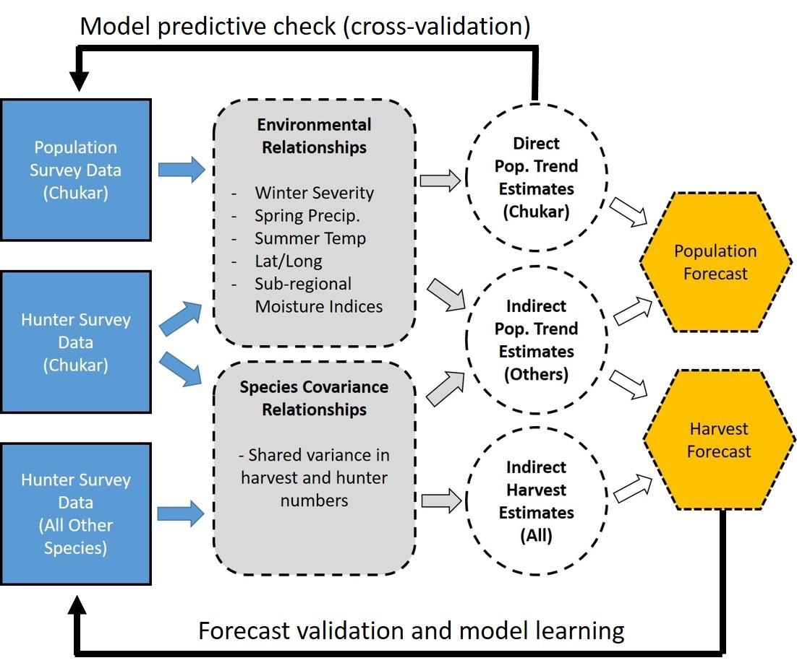

**Figure 2.**  Conceptual model describing the relationship between data (blue boxes), variable relationships and species covariances (grey boxes), estimates of harvest and population trajectory (circles), and model forecast outcomes (hexagons). We propose to validate the models in two ways, using a cross-validation technique for survey data, and using an iterative learning and model validation approach for the harvest forecasts.

1. **Beneficial Outcomes**: Traditionally NDOW has provided chukar hunters with an assessment of the hunting season outlook based on surveys collected via helicopter during late summer. These surveys are expensive to conduct and also expose biologists to risks associated with low-altitude helicopter flight. Nevertheless, they provide among the only information on long-term chukar population dynamics and have traditionally offered hunters important insights into their upcoming season. For most other species, no such information exists. At the same time, NDOW has collected an impressive volume of data on hunter success through annual surveys of a subset of small game hunters. These data remain largely unexplored, but offer great potential to inform the department on long-term patterns in populations of game species that have received little attention. Our project takes advantage of these previously under-utilized datasets to develop a product that simultaneously provides valuable information to a major stakeholder group (upland game hunters) and will maximize use of existing data to inform status assessments for Nevada’s upland game populations. Ultimately this seeks to increase information availability at a lower cost and with less risk to staff compared to traditional methods.

We anticipate this project will result in a web application, a project database, and at least one peer-reviewed publication. We will also present the work to local, national, and international professional and public audiences as opportunities present.

1. **Project Schedule**: Flexible
   1. **Start Date**: upon contract execution
   2. **End Date**: 18 months + start date
2. **Relationship to NDOW plans:**
3. **NEPA Compliance:**
4. **Cost Summary:**

**Budget Justification**

***Personnel***

*Faculty Summer Salary -* Summer salary is requested for E. Blomberg for 0.38 months (~10 days) during summer 2021 to travel out of state to work with consulting biologists on data analysis and modelling. Total amount = $3,450.

***Fringe Benefits***

Fringe benefits are charged to the PI’s summer salary using the University of Maine’s rate of 8.1%. Total amount = $279

**Travel:**

*Out of state travel -* Travel reimbursement (airfare, hotel, and/or per diem at a rate of $46 per day) for approximately 10 days summer travel to Montana to work with consulting biologist and/or Nevada to present results of work to sponsor. $2,581 total.

**Other Direct Costs:**

*Consultant Services* – Fees for contract biologist to conduct data analysis in support of project objectives. Independent contractor Dr. Daniel Gibson will act as the consulting biologist at a rate of $262.23 per day, for an estimated 120 days required to complete the analysis and project reporting. The consulting biologist will develop all analytical tools for population estimation and forecasting associated with the grant deliverables. Total amount = $31,468.

***Facilities & Administrative Costs***

UMaine facilities and administrative (F&A) costs to will be assessed at rate of 26% for off-campus research, given that work will not be conducted at the UMaine campus. Total amount = $9,822

**Total Request: $47,600**

1. **Is this Project Going to Continue After FY21?** Yes __X__ No ___
2. **If Yes, is this Going to be an Annual, Recurring Project?** Yes ____ No __**X**__
3. **If it is Going to Continue After FY21, Define the Total Dollars to be Spent During Each Fiscal Year:**

Proposed: $ 12,500.00 (FY22)

These funds would be used to provide the expertise to trouble shoot issues related to the model update and forecasting procedure for the following year (FY22), as well as determine the extent to which the model forecasting can be automated in the future. It represents approximately 2 months of salary.

1. **Would Funds from this Program Be Used for State Matching Purposes?** Yes __ No ___
2. **If Yes, Which Federal Grant Would the Matching Funds be Used For?**
3. **Describe What Type of Contract(s) Will be Needed or Currently Exists (if any) to Complete Work Under this Project (Independent Contract, Sub-grant Agreement, Inter-local Agreement or Good of the State Contract):**

We would need to submit an official proposal/budget through the OSP at Virginia Tech.

**If a Contract Exists, or is Needed**